Fit for Life: Home Personal Coach

Dr.Sivakumar Ponnusamy1, Mohsen Ba Omar2, Fahad Alshunaybir3, Mohsen Alanazi4, Mwaz Alzebak5

**s.ponnusamy@seu.edu.sa**

Assistant Professor1, Final Year (Level Eight) 2,3,4,5, Department of Computer Science, College of Computing and Informatics, Saudi Electronic University,

Riyadh, Kingdom of Saudi Arabia

.

# Introduction

The development of mobile applications in recent years has been a huge explosion that led to the transformation of normal life into a life linked to mobile services and applications, here in this introduction we presentation an application called Fit for Life: Home Personal Coach which cares about healthy life and provide all the amenities to reach the goal of people. In return we provide them with a special coach specialized in certain areas that the trainee looks forward.

## Product

This document describes the Software Requirements Specification (SRS) for Fit for Life: Home Personal Coach is a mobile application android that link trainees and coaches using phone’s GPS capability. The requirements of the trainee must be meet with coaches. Moreover, the trainee has appropriated to choose of which coach be achieve the goals. The system shows the available coach that is fit with the goal of the trainee. In addition, the coaches have bio to give brief description important information such as the Expertness of working as coach, Education and Specialty. Fit for Life: Home Personal Coach provide service for the people who need an individual health program or who cannot go to the gym or have problems with obesity. For this purpose, we must induce new Mobile Application for Fit for Life.

## Scope

To solve the problem of people who register for gym and cannot complete or not continue to go to gym, or people who want to exercise individually under the supervision of a certified trainer and specialist within the scope of the home, and there is also the problem of people who suffer from obesity that causes social cohesion and lack of self-confidence. Therefore, we have limited the Fit for Life: Home Personal Coach app, and narrow our scope to these people and will focus on the things that are important for them to register as a trainee or coach and choose the goals that the trainee to reach them through the coach and the trainer determines what practical and scientific expertise to help the trainee to choose his coach based on "What will I accomplish?".

## Business Goals

* Increase employment opportunities for coach.
* Support feature of individual training between trainee and coach at home.
* Increase success rate of the exercise and health program that provided by the coach to the trainees, and the improvement observed during the individual exercises.
* Solve the problem of people suffering from lack of self-confidence in society due to obesity or other diseases by providing a special coach for them at home.
* Protecting the community from serious diseases and raising awareness of the importance of exercise and health programs.

## Literature Review

Fit for Life: Home Personal Coach app is uses the Android environment and the SQLite

to develop the application. Therefore, this literature review is organized into three main sections. Section 1 starts by describing ‘Android’ in general and the android compatibility with describe OS Architecture. Section 2 introduces the history of database and the SQLite working with Android OS. Finally, section 3 introduces Similar Applications with Compare them with our application and what we offer from a solution.

#### Coach at Home website

In the Personal Trainer Luxembourg - Coach at Home website they are providing train people of all ages and skill levels who seek lining a balanced, healthy lifestyle. One of the advantages that help us to looking well and provided in our application is “anytime and anywhere Our personal trainers come to your ome, park or workplace - anytime, anywhere no gym needed, we’ll show you that with your own bodyweight and our know-how, you can achieve unbeatable results”. (Personal Trainer Luxembourg - Coach at Home, n.d.)

According in Coach at Home website they do not offer an application service on smart phones and this is what we provide in our application. Based on this, we know that most people have a mobile phone at anytime and anywhere, making it easier and more efficient to use our application and looking for a coach

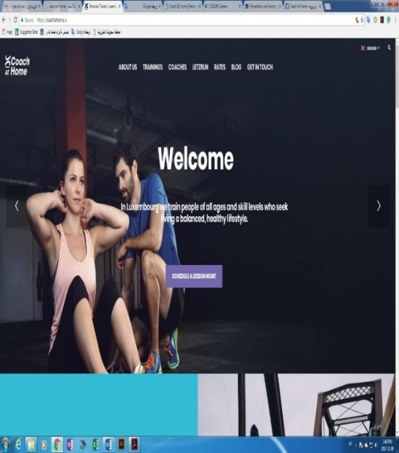

Figure 1.5.3.1 Coach at Home website

#### Coach @ Home | Personal Coaching Graz website

At Coach @ Home the mine idea of training is exist, but they do not offer concept of offer an application service on smart phones it’s just at website only than we decided that application is offer at smart phone as an application and get easier to user get coach at home by phone only no need to open the PC or Laptop.

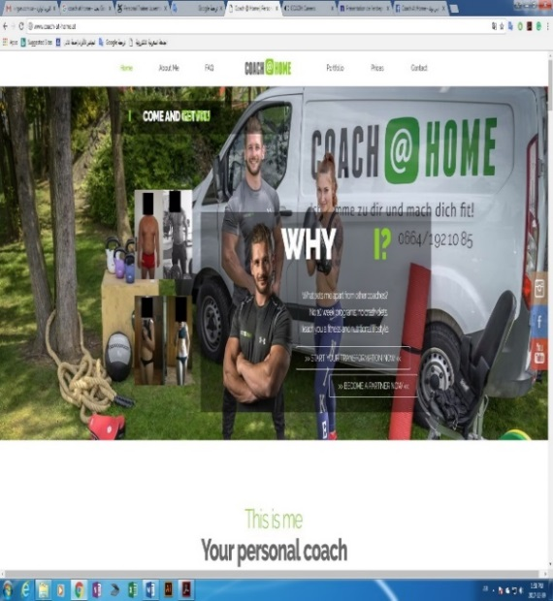

Figure 1.5.3.2 Coach @ Home website

A close up of a mans face

Description generated with very high confidence

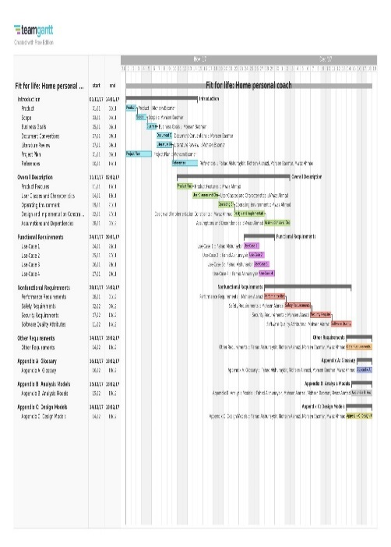

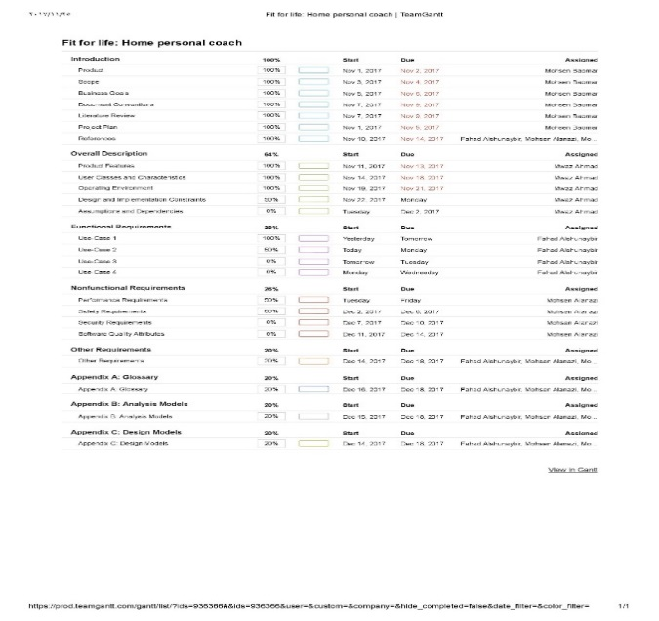

### Gantt Chart

Figure 1.6.3 The Arrow Diagramming Method

# Overall Description

## Product Features

With the Fit for life: Home personal coach, is application will help people who don't have time to go to gym and help the by provide coaches the app is new idea so it's a good point and the design for the will be clear and simple for attract customers. The features of the Fit for life: Home personal coach.

The following list offers a brief outline and description of the main features and functionalities of the Fit for life: Home personal coach:

1. User Registration & Welcome, Only appears once (the first time the application is run), Allows the user to register with Fit for life: Home personal coach server.

2. The users will be able to search for coach and select the appropriate. The result will be based on the criteria the user inputs, and the result of the search will be viewed in a list view. and this list will appear the nearest coach.

3.The Application will allow the user sending and receiving text massage inside the Application. the trainee will be feeling rested, because the coach will be focus with him only with him step by step.

4.Gps Tracking for find a nearest coach.

5.The coach will give a plan for trainee to do diet to lose/ up weight as want. The plan will include daily food which needed and quantity of water for drink and a lot.

6. the coach will give 10% money for the manager of app for each trainee.

7. Feedback/ Rating for every coach’s  Some of a drawback is about the project is the "TIME' because the coach may have a lot of thing to do and don't have more time to going to each trainees and other thing he appropriate time between trainees and coach and and the traffic may be a small drawback (may the coach belated or something like that).

## User Classes and Characteristics

There are three types of users that interact with the system**: Coach, Trainee, and Administrators.** Each of these three types of users has different use of the system so each of them has their own requirements.

**Trainee**

The Fit for life:  Home personal coach:  can only use the application to find a coach to help them.  This means that the user has to be able to search for a coach, choose a coach from that search and then navigate to it. In order for the users to get a relevant search result there are multiple criteria the users can specify, and all results matches all of those.

**Coach**

The coach will use the mobile application also. There they will be able manage the information about their plans, and information of the coach experience, for example a description of the coach, contact information and their experience .and submit some videos about techniques exercises sport.

**Administrators**

The administrators are managing the overall application so there is no incorrect information within it. and the administrator can manage the data of the database.

## Operating Environment

Operating environment for the application: The project will use **Android studio, java and SQL.** The main component of the Fit for life: Home personal coach project is the software application, which will be limited to the Android operating system (specifically Android 4.0.3 and above). The Fit for life: Home personal coach database will be stored on the server using MySQL.

The project will use Android Studio, Java language, SQL.

* **Android Studio**,a lot of features which can help to build this program, and android studio has emulator which can help to run the application as test.
* **Database: SQL / SQLITE,**afeature which will helps to store the data.

## Design and Implementation Constraints

Creating a user interface which is both effective and easily to use will pose a difficult challenge.

* Application will be running on the android phone.
* Application Data shall be stored in the SQL Database.
* The Internet connection is also a constraint for the application. Since the application fetches data from the database over the Internet.
* The database may affect system performance as data increases.
* Language requirements: software must be multilingual, including the following languages: English.

## Assumptions and Dependencies

* One assumption about the product is that it will always be used on mobile phones that have enough performance.
* Each User must have a UserID and password to contact with coach.
* Internet connection is a must.

Time Dependencies

The features of application are divided into two groups: core features and additional features.

Core features are crucial to the basic functionality of the application. These features must all be implemented in order for the application to be useful. Optional features, however, are not critical to the function of the application.They are usability improvements and convenience enhancements that may be added after the application has been developed.

Thus, the implementation of these features is entirely dependent upon the time spent designing and implementing the core features. The final decision on whether or not to implement these features will be made during the later stages of the design phase.

Hardware dependencies

Some of the additional features rely on hardware components present in Android handsets.

The camera will be used if the coach wants to see body for the user to know how help him well, Consequently.this feature is entirely reliant upon the ability to access the camera’s functionalities. In addition, the application will use the handset’s location sensors (GPS) To find the nearest coach.

Both the camera and the GPS functionalities will be achieved using the API provided by the Android operating system.

# Functional Requirements

## Use-Case (Trainee)

|  |  |  |  |
| --- | --- | --- | --- |
| **Identifier** | | Reserve coach | |
| **Purpose** | | Search and Reserve a coach | |
| **Priority** | | High | |
| **Pre-conditions** | | Must sign up before | |
| **Post-conditions** | | Trainee will get the coach schedule | |
| **Typical Course of Action** | | | |
| **S#** | **Actor Action** | | **System Response** |
| **1** | Trainee | | 1. Sign in 2. Search for a coach 3. Request a coach 4. Pay for service |

Table 3.1: Reserve coach

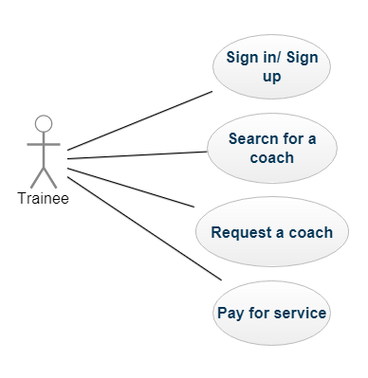

Figure Use-Case Diagram Trainee

## Use-Case (Coach)

Table 3.2: Accept / reject requests

|  |  |  |  |
| --- | --- | --- | --- |
| **Identifier** | | Accept / reject requests | |
| **Purpose** | | Accept or reject requests which comes from Trainee | |
| **Priority** | | High | |
| **Pre-conditions** | | Must sign up and audited by administrator if he qualifies or not | |
| **Post-conditions** | | Start coaching the trainee and get his money | |
| **Typical Course of Action** | | | |
| **S#** | **Actor Action** | | **System Response** |
| **1** | Coach | | 1. Sign in Sign Out 2. Accept /Reject requests 3. Receive fee from trainee |

Use-Case (Administrator)

Table 3.3: Maintain and auditing coaches

|  |  |  |  |
| --- | --- | --- | --- |
| **Identifier** | | Maintain and auditing coaches | |
| **Purpose** | | Manage and maintain coaches & trainee info | |
| **Priority** | | High | |
| **Pre-conditions** | | Must coaches and trainees signed up | |
| **Post-conditions** | | audit coaches and trainee’s info | |
| **Typical Course of Action** | | | |
| **S#** | **Actor Action** | | **System Response** |
| **1** | Administrator | | 1. Receive fee from trainee 2. Update and audit info 3. Approve new coach 4. System maintenance |

# Nonfunctional Requirements

## Performance Requirements

Performance, security, privacy and availability are crucial to the success or failure of mobile application software system. Selecting the right algorithms and data structures should always be your priority. There are two basic rules for writing efficient code: first don't do work that you don't need to do, and second is that don't allocate memory if you can avoid it. Therefore, certain to be running on multiple types of hardware. Different versions of the VM running on different processors running at different speeds. It's not even mostly the case that you can just say, "device X is a factor F faster/slower than device Y", and standardize your results from one device to others. To ensure the application fit for life home personal coach performs well across a wide variety of devices is by ensure your code is efficient at all levels is by:

* Avoid creating unnecessary objects
* Prefer static over virtual
* Use static final for constants
* Use enhanced for loop syntax
* Avoid using floating-point
* Know and Use the Libraries
* Use Native Methods Carefully
* Performance Myths
* Always Measure

Responsiveness: This requirement ensures that your application is ready to respond to a user’s input or an external event no matter what it’s doing currently. For example, does your application allow the user to switch to another function even while it’s busy calculating a route?

## Safety Requirements and conclusion

First when we create our application Fit for Life: Home Personal Coach we should make external a backup to secure our app, data, and customer data to be able to Maintainability, upgrade, and update the application. Maintainability is requirement that you will be able to finds bugs and fixes them easily and smoothly in our application. For example, if a map is incorrect, we can you fix the problem simply by downloading a correct map. The customer information is our priority to keep them save and hiding. Therefore, we put identification, authentication, and authorization measures in place.

## References

1. *Android*. (n.d.). Retrieved 12 5, 2017, from wikipedia.org: http://en.wikipedia.org/wiki/Android_(operating_system)
2. *Android Compatibility*. (n.d.). Retrieved 12 5, 2017, from Google: http://developer.android.com/guide/practices/compatibility.html
3. Bachman, C. W. (1973, 11). The programmer as navigator. *Communications of the ACM, 16*(11). doi:10.1145/355611.362534
4. *Coach @ Home | Personal Coaching Graz*. (n.d.). Retrieved from Personal Coaching: http://www.coach-at-home.at/
5. Codd, E. F. (1970). A Relational Model of Data for Large Shared Data Banks. *Communications of the ACM, 6*(13). doi:10.1145/362384.362685
6. *Database*. (n.d.). Retrieved 12 6, 2017, from wikipedia.org: http://en.wikipedia.org/wiki/Database
7. Feiler, J. (2015). In *Introducing SQLite for Mobile Developers.* Apress, Berkeley, CA.
8. Kulkarni, A. A., & Kulkarni, P. A. (2015, January). A STUDY OF ANDROID OPERATING SYSTEM WITH. *International Journal of Advanced Technology in Engineering and Science, 01*(03), pp. 593-598.
9. *Personal Trainer Luxembourg - Coach at Home*. (n.d.). Retrieved from Coach at Home: https://coachathome.lu/
10. *Picture*. (n.d.). Retrieved 12 5, 2017, from wikimedia.org: http://upload.wikimedia.org/wikipedia/commons/thumb/d/db/Android_robot_2014.svg/500px-Android_robot_2014.svg.png
11. *Platform Architecture*. (n.d.). Retrieved from developer.android.com: https://developer.android.com/guide/platform/index.html#api-framework
12. *Welcome to the Android Open Source Project!* (n.d.). Retrieved 12 6, 2017, from Google: http://source.android.com/
13. *Android Camera*. (n.c.). from Google: <http://developer.android.com/reference/android/hardware/Camera.html>
14. *Android location*. (n.l.). from Google:
15. <http://developer.android.com/guide/topics/location/index.html>